Q1.

SELECT

JF.LOCATION_ID,

LD.LOCATION_NAME,

JF.SALES_CLASS_ID,

SCD.SALES_CLASS_DESC,

TD.TIME_YEAR CONTRACT_YEAR,

TD.TIME_MONTH CONTRACT_MONTH,

SCD.BASE_PRICE,

SUM(JF.QUANTITY_ORDERED) QUANTITY_ORDERED,

SUM(JF.QUANTITY_ORDERED)* SUM(JF.UNIT_PRICE) JOB_AMOUNT

FROM W_JOB_F JF, W_LOCATION_D LD, W_SALES_CLASS_D SCD, W_TIME_D TD

WHERE JF.LOCATION_ID = LD.LOCATION_ID

AND JF.SALES_CLASS_ID = SCD.SALES_CLASS_ID

AND JF.CONTRACT_DATE = TD.TIME_ID

GROUP BY JF.LOCATION_ID, LD.LOCATION_NAME, JF.SALES_CLASS_ID, SCD.SALES_CLASS_DESC,

TD.TIME_YEAR ,

TD.TIME_MONTH ,

SCD.BASE_PRICE;

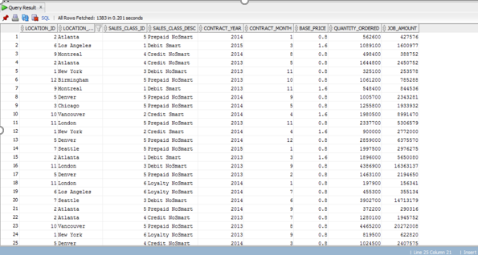

Q2.

CREATE VIEW vw_InvoiceRevenueSummary AS

SELECT JF.JOB_ID,

JF.LOCATION_ID,

LD.LOCATION_NAME,

JF.UNIT_PRICE ,

JF.QUANTITY_ORDERED,

TD.TIME_YEAR CONTRACT_YEAR,

TD.TIME_MONTH CONTRACT_MONTH,

SUM(INF.INVOICE_AMOUNT) INVOICE_AMOUNT,

SUM(INF.INVOICE_QUANTITY) INVOICE_QUANTITY

FROM W_JOB_F JF,

W_LOCATION_D LD,

W_INVOICELINE_F INF,

W_JOB_SHIPMENT_F JSF,

W_SUB_JOB_F SJF,

W_TIME_D TD

WHERE JF.LOCATION_ID = LD.LOCATION_ID

AND JF.JOB_ID = SJF.JOB_ID

AND SJF.SUB_JOB_ID = JSF.SUB_JOB_ID

AND JSF.INVOICE_ID = INF.INVOICE_ID

AND JF.CONTRACT_DATE = TD.TIME_ID

GROUP BY JF.JOB_ID,

JF.LOCATION_ID,

LD.LOCATION_NAME,

JF.UNIT_PRICE ,

JF.QUANTITY_ORDERED,

TD.TIME_YEAR,

TD.TIME_MONTH ;

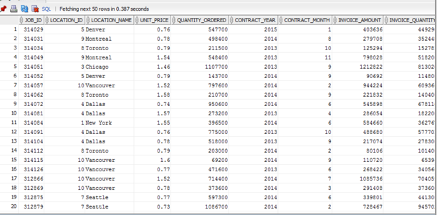

Q3.

CREATE VIEW vw_SubJobCostSummary AS

SELECT JF.JOB_ID,

JF.LOCATION_ID,

LD.LOCATION_NAME,

TD.TIME_YEAR CONTRACT_YEAR,

TD.TIME_MONTH CONTRACT_MONTH,

SUM(SJF.COST_LABOR) COST_LABOR,

SUM(SJF.COST_MATERIAL) COST_MATERIAL,

SUM(MACHINE_HOURS * RATE_PER_HOUR) COST_MACHINE,

SUM(SJF.COST_OVERHEAD) COST_OVERHEAD,

SUM(SJF.COST_OVERHEAD) + SUM(SJF.COST_LABOR) + SUM(SJF.COST_MATERIAL) + SUM(MACHINE_HOURS * RATE_PER_HOUR) COST_TOTAL,

SUM(SJF.QUANTITY_PRODUCED) QUANTITY_PRODUCED,

CASE

WHEN SUM(SJF.QUANTITY_PRODUCED) = 0

THEN 0

ELSE (SUM(SJF.COST_OVERHEAD) + SUM(SJF.COST_LABOR) + SUM(SJF.COST_MATERIAL) + SUM(MACHINE_HOURS * RATE_PER_HOUR))/SUM(SJF.QUANTITY_PRODUCED)

END UNIT_COST

FROM W_JOB_F JF,

W_LOCATION_D LD,

W_JOB_SHIPMENT_F JSF,

W_SUB_JOB_F SJF,

W_MACHINE_TYPE_D MTD,

W_TIME_D TD

WHERE JF.LOCATION_ID = LD.LOCATION_ID

AND JF.JOB_ID = SJF.JOB_ID

AND SJF.SUB_JOB_ID = JSF.SUB_JOB_ID

AND SJF.MACHINE_TYPE_ID = MTD.MACHINE_TYPE_ID

AND JF.CONTRACT_DATE = TD.TIME_ID

GROUP BY JF.JOB_ID,

JF.LOCATION_ID,

LD.LOCATION_NAME,

TD.TIME_YEAR ,

TD.TIME_MONTH ;

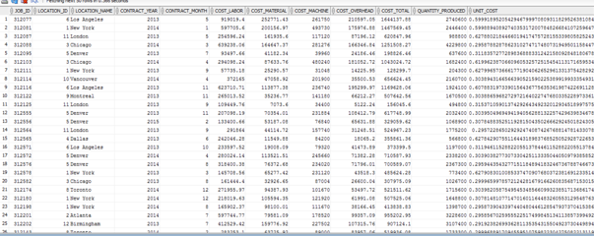

Q4.

SELECT JF.LOCATION_ID,

LD.LOCATION_NAME,

JF.SALES_CLASS_ID,

SCD.SALES_CLASS_DESC,

TD.TIME_YEAR INVOICE_SENT_YEAR,

TD.TIME_MONTH INVOICE_SENT_MONTH,

SUM(INF.QUANTITY_SHIPPED) - SUM(INF.INVOICE_QUANTITY) RETURN_QUANTITY,

SUM(INF.INVOICE_AMOUNT) INVOICE_AMOUNT

FROM W_JOB_F JF,

W_LOCATION_D LD,

W_INVOICELINE_F INF,

W_JOB_SHIPMENT_F JSF,

W_SUB_JOB_F SJF,

W_TIME_D TD,

W_SALES_CLASS_D SCD

WHERE JF.LOCATION_ID = LD.LOCATION_ID

AND JF.JOB_ID = SJF.JOB_ID

AND SJF.SUB_JOB_ID = JSF.SUB_JOB_ID

AND JSF.INVOICE_ID = INF.INVOICE_ID

AND INF.INVOICE_SENT_DATE = TD.TIME_ID

AND JF.SALES_CLASS_ID = SCD.SALES_CLASS_ID

GROUP BY JF.LOCATION_ID,

LD.LOCATION_NAME,

JF.SALES_CLASS_ID,

SCD.SALES_CLASS_DESC,

TD.TIME_YEAR,

TD.TIME_MONTH;

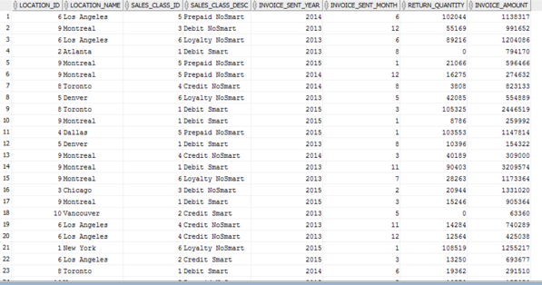

Q5.

CREATE VIEW vw_SHIPMENTDELAYS_DATEPROMISED AS

SELECT JF.JOB_ID ,

LD.Location_ID ,

LD.LOCATION_NAME,

JF.SALES_CLASS_ID,

SCD.SALES_CLASS_DESC,

JF.DATE_PROMISED,

X1.Last_Shipment_Date,

JF.QUANTITY_ORDERED,

X1.SumDelayShipQty AS SHIPPED_QTY_DELAYED,

GETBUSDAYSDIFF(X1.Last_Shipment_Date,JF.DATE_PROMISED) BUSINESS_DAYS_DIFF

FROM W_JOB_F JF,

W_LOCATION_D LD,

W_SALES_CLASS_D SCD,

(SELECT W_SUB_JOB_F.JOB_ID,

MAX(actual_ship_Date) AS Last_Shipment_Date,

SUM ( actual_Quantity ) AS SumDelayShipQty

FROM W_JOB_SHIPMENT_F,

W_SUB_JOB_F,

W_Job_F

WHERE W_SUB_JOB_F.SUB_JOB_ID = W_JOB_SHIPMENT_F.SUB_JOB_ID

AND W_Job_F.Job_Id = W_SUB_JOB_F.JOB_ID

AND Actual_Ship_Date > Date_Promised

GROUP BY W_SUB_JOB_F.JOB_ID

) X1

WHERE X1.JOB_ID = JF.JOB_ID

AND JF.LOCATION_ID = LD.LOCATION_ID

AND JF.SALES_CLASS_ID = SCD.SALES_CLASS_ID;

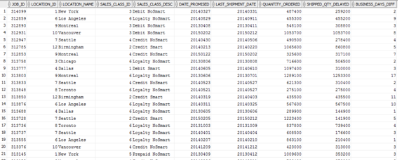

Q6.

CREATE VIEW vw_SHIPPEDDATESTATS AS

SELECT JF.JOB_ID ,

LD.Location_ID ,

LD.LOCATION_NAME,

JF.SALES_CLASS_ID,

SCD.SALES_CLASS_DESC,

JF.DATE_SHIP_BY,

X1.FirstShipDate,

GETBUSDAYSDIFF(X1.FirstShipDate,JF.DATE_SHIP_BY) AS BUSINESS_DAYS_DIFF

FROM W_JOB_F JF,

W_LOCATION_D LD,

W_SALES_CLASS_D SCD,

(SELECT W_SUB_JOB_F.JOB_ID,

MIN(Actual_Ship_Date) AS FirstShipDate

FROM W_JOB_SHIPMENT_F,

W_SUB_JOB_F

WHERE W_SUB_JOB_F.SUB_JOB_ID = W_JOB_SHIPMENT_F.SUB_JOB_ID

GROUP BY W_SUB_JOB_F.JOB_ID

) X1

WHERE X1.JOB_ID = JF.JOB_ID

AND JF.LOCATION_ID = LD.LOCATION_ID

AND JF.SALES_CLASS_ID = SCD.SALES_CLASS_ID

AND X1.FirstShipDate > JF.DATE_SHIP_BY;

